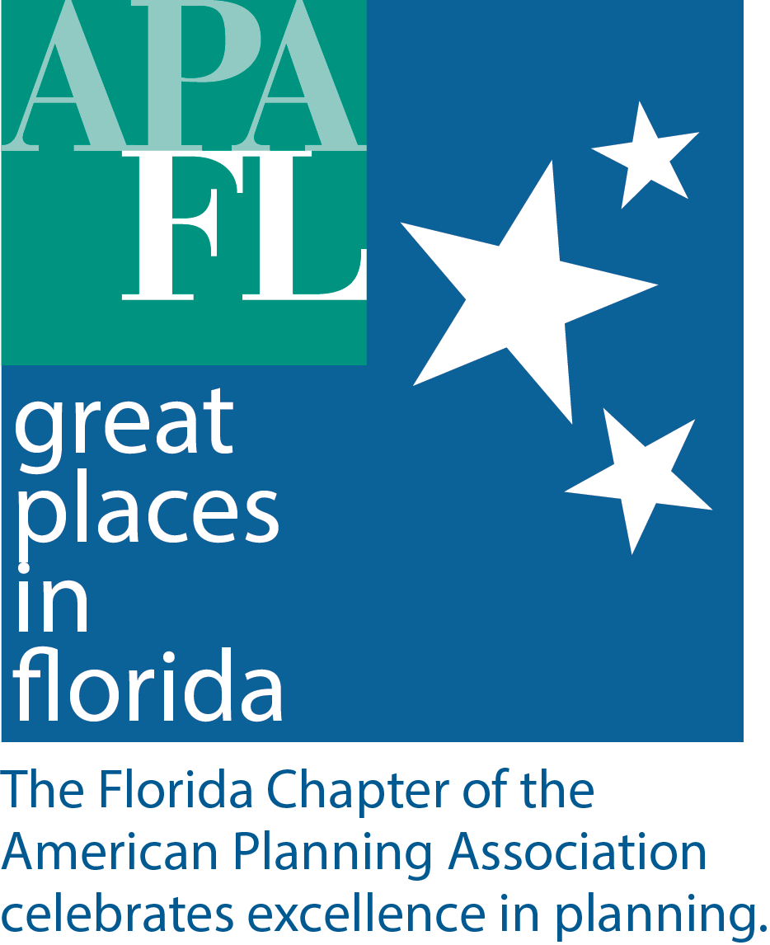

July 2, 2020

Nominations for APA Florida Great Places in Florida Award Open July 6
Tallahassee – The Florida Chapter of the American Planning Association (APA FL) announces the 7th annual Great Places in Florida award program. This initiative celebrates Great Places in Florida and the communities that sustain them.

Great Places focuses on unique, memorable places that work for the good of their community and attract people to visit them. The award is an annual selection of places that represent the gold standard of having a true sense of place, cultural and historical interest, community involvement and a vision for tomorrow. Nominees should contribute to the greater community’s social, economic, and environmental well-being for the long term. Any Neighborhoods, Downtowns, Streets, or Public Places in your community with these attributes are eligible for submission.

Finalists will be chosen by a panel of multidisciplinary experts, and the Great Places in Florida winner will be chosen by the public in the People’s Choice voting round.

Contest deadlines are as follows:
- Nomination period opens on July 6, 2020.
- Nominations due by Aug. 7 at 5 pm ET.
- Selection committee will deliberate and announce finalists on Aug. 28, 2020.
- People’s Choice voting runs Sept. 8-25, 2020.
- The 2020 Great Places in Florida winner will be announced on Monday Oct. 5 to kick off to National Community Planning Month activities.

To nominate your favorite place, visit the APA Florida website at florida.planning.org/greatplaces. All nomination instructions and submission forms can be found on the site.

Questions about the APA Florida Great Places program can be addressed to Executive Director Alex Magee at fapa@floridaplanning.org.

